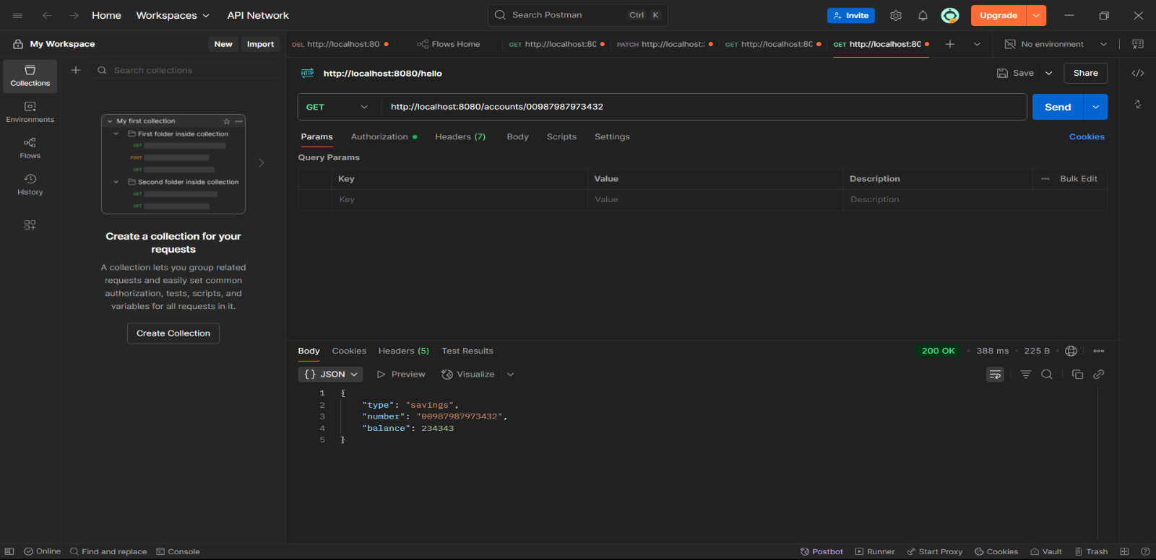**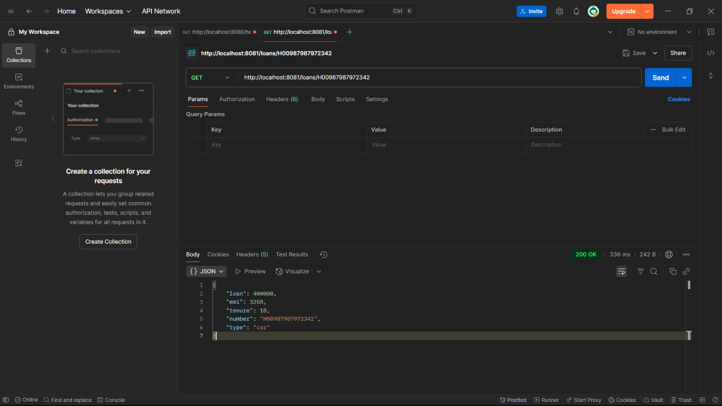Account Microservice on** [**http://localhost:8080/accounts/{number}**](http://localhost:8080/accounts/%7bnumber%7d)

**Loan Microservice on**

**http://localhost:8081/loans/{number}**